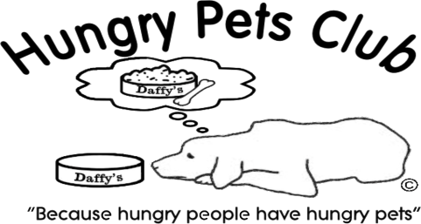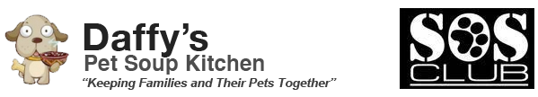

COMMUNITY PARTNER AGREEMENT
With DAFFY’S ______________________ PET SOUP KITCHEN

I, __________________________________________________________________ (name of individual or business), agree to be a charitable partner with SOS Club, Inc. (a 501(c)3 non-profit organization) d/b/a Daffy’s Pet Soup Kitchen and Hungry Pets Club in their efforts to feed and care for family pets in our community by providing on-going financial sponsorship and by collecting pet food/supplies for Daffy’s Pet Soup Kitchen/Hungry Pets Club at my place of business.
To qualify as a community partner:
- I will make a donation of $75.00 at the time of acceptance of this agreement as a one-time set-up fee for the production of my logo for the food bank unit.
- I will email a high resolution image of my company logo to thesosclubofga@yahoo.com as soon as possible.
- I will contribute $75.00 per month via recurring (auto-debit) payment on Paypal to thesosclubofga@yahoo.com to begin on ____________________________ (date).
- I will place an approved collection bin in my place of business and notify SOS Club when bin is ¾ full. I will not allow anyone (other than a representative of Daffy’s) to remove any item(s) from the bin without prior written permission from SOS Club.
- I agree to promote SOS Club’s mission and programs to my customers and I agree not to collect pet food/supplies for any other pet-related charity without prior written permission from SOS Club. *Daffy’s is always eager to help other local non-profits and would simply like to be made aware of any other charitable events held at your location so that we may help to promote it (and your business).
- I agree to allow SOS Club to use and publish, for promotional purposes, any photographs or videos taken at my place of business.
In exchange for meeting the conditions above, our community partners will receive:
- One approximately 12”x12” logo displayed on the portable pet soup kitchen which is to be placed in a highly-visible location such as a shopping center or church parking lot. *Larger ad space may be available – please inquire if interested.
- A plaque indicating my support of our community to display in my place of business.
- A decorative pet food collection bin for my place of business (approximately 3’x4’).
- Listing on Daffy’s main website (www.daffyspetsoupkitchen.org).
- Acknowledgement of my business in each SOS Club e-newsletter (published at least quarterly).
- Recognition on all of Daffy’s social media sites – at present we have close to 10,000 likes, friends, fans, followers, etc. on 8 different networks. *Please “Like” us on Facebook so that we may tag you in posts.
- Promotion at all Daffy’s fundraising events.
- Half off standard booth space rental at all Daffy’s-sponsored events.
- Listing on Hungry Pets Club website as a drop off location.
- Hungry Pets Club sticker or decal for front door or window of my business.

Agreed to this _________ day of ______________________________, 20____ by:

Printed name and title of individual or business representative:

_____________________________________________________________________________________________
Signature of individual or business representative:

_____________________________________________________________________________________________
Address of individual or business representative:

_____________________________________________________________________________________________
Phone number and e-mail of individual or business representative:

_____________________________________________________________________________________________

Printed name and title of SOS Club representative:
____________________________________________________________________________________________
Signature of SOS Club representative:
_____________________________________________________________________________________________

SOS Club, Inc., P.O. Box 1640, Lilburn, GA 30048 404-345-6821 thesosclubofga@yahoo.com www.daffyspetsoupkitchen.org

